**TITLE OF LAB: (HALF WAVE AND FULL WAVE RECTIFIER)**

**Lab No. #04**



**Spring 2022**

**CSE-206L Electronic Circuits Lab**

Submitted by

**Safi Ullah Khan : 20PWCSE1943**

Class Section: **B**

“On my honor, as student of University of Engineering and Technology, I have neither given nor received unauthorized assistance on this academic work.”

Student Signature: ______________

Submitted to:

**Engr. Abdullah Hamid**

(Monday, June 19th, 2022)

**Department of Computer Systems Engineering**

**University of Engineering and Technology, Peshawar**

**Objectives:**

* To know about half and full wave rectifiers.
* To get familiar with the graphs of both rectifiers.

**Software Used:**

* We will use proteus software to design half and full wave rectification circuit and show the output and input graph using Oscilloscope.

**Component Used:**

* Resistor
* Ac voltage Source
* Diode (PIV should be greater)
* Wires
* Ground
* Oscilloscope

**Equipment:**

* Oscilloscope
* Function Generator

**Components:**

* Diodes: Silicon (D1N4007)
* Resistor: 2 kΩ,
* In this lab we will use Silicon (D1N4007) because it don’t break quickly as compare to Silicon (D1N4002).

**Procedures of Proteus:**

1. Open Proteus ISIS Schematic Capture.

2. Select the Component Mode from the left Toolbar.

3. Click on P (Pick from Libraries)

4. Add all the required components.

5. Res for resistor battery to add battery, diode to add diode.

6. Place the components on the workspace.

7. Wire up the circuit.

8. Click on the terminal mood to add ground. 9. Click on the instrument to add Voltmeter.

10. Click on Play Button on the bottom left to start simulation.

11. To Design a PCB layout Click on the PCB layout button.

12. Left click on the battery of the circuit and select package tool otherwise battery will not work in PCB designing.

**Half Wave Rectification:**

* A half-wave rectifier converts an AC signal to DC by passing either the negative or positive half-cycle of the waveform and blocking the other. Half-wave rectifiers can be easily constructed using only one diode, but are less efficient than full-wave rectifiers.

**efficiency of a half-wave rectifier:**

* Since only half of the input waveform is passed, the efficiency of a half-wave rectifier is lower than that of a full-wave rectifier. The maximum efficiency of a half-wave rectifier is about 40.5%, and the maximum efficiency of a full-wave rectifier is twice that.

**Circuit Diagram:**

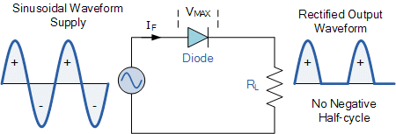

**Half Wave rectifiers:**

I used Vsin for half wave since I was used to it.

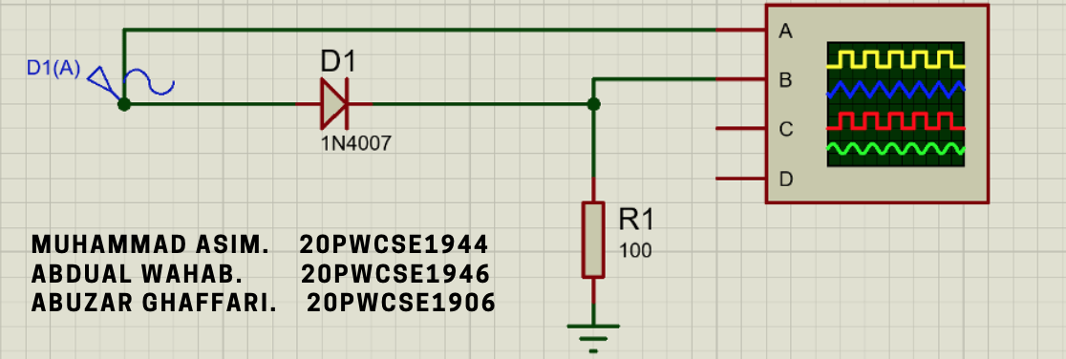

Figure 1: Schematic for half wave rectifier

The oscilloscope Output is below.

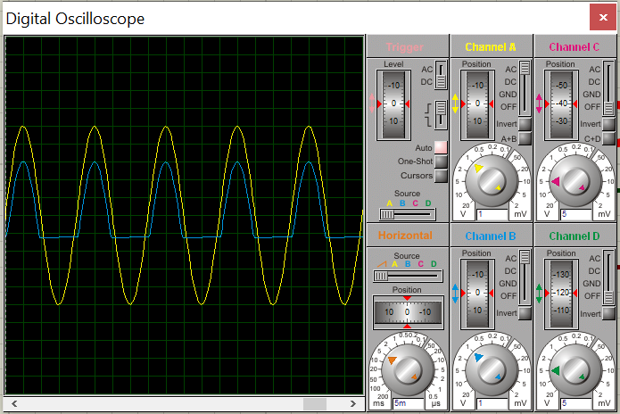

**Lab picture for half wave Rectefier:**

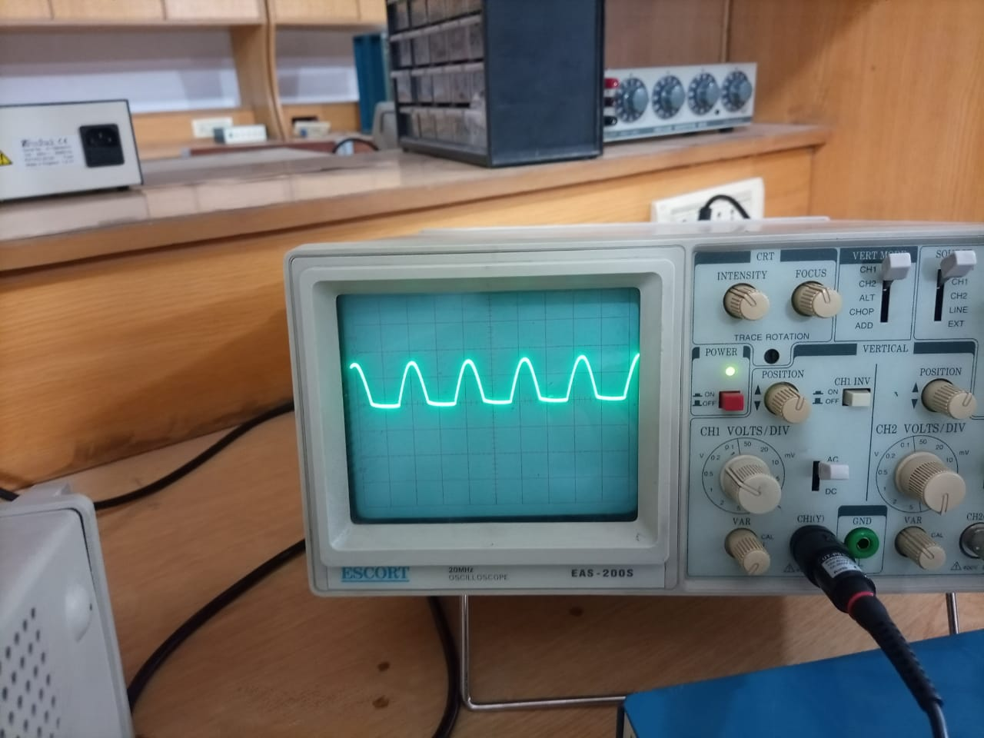

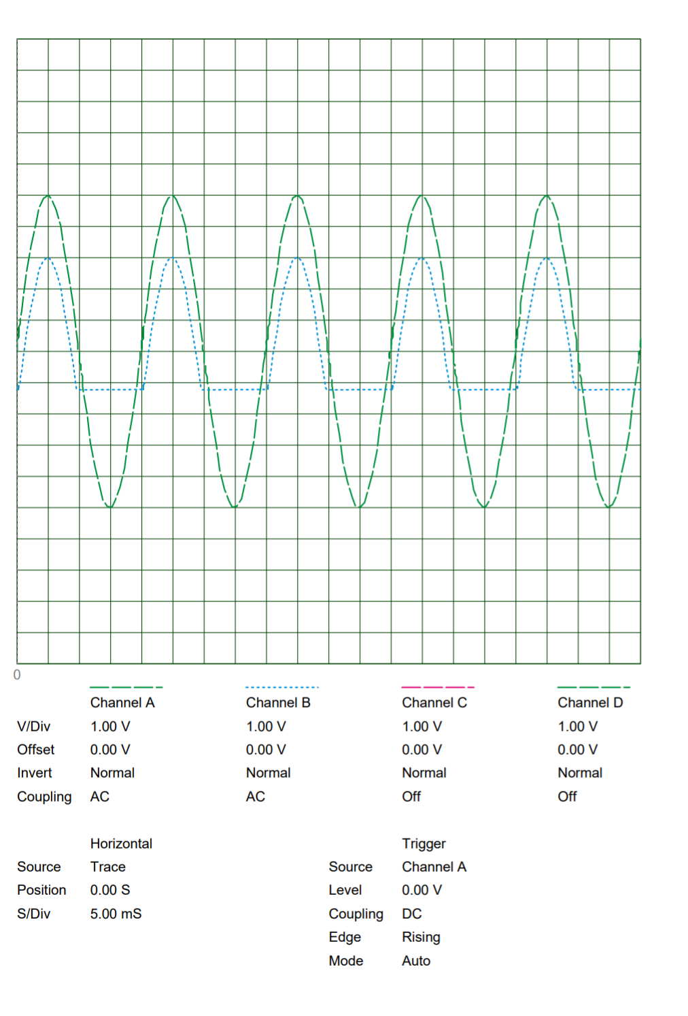

Previous page was a print of the Proteus oscilloscope. Since I was having trouble finding a way to enlarge size of the oscilloscope in proteus, I took a print as pdf and pasted it on entire page.

I then moved on to building full wave rectifier.

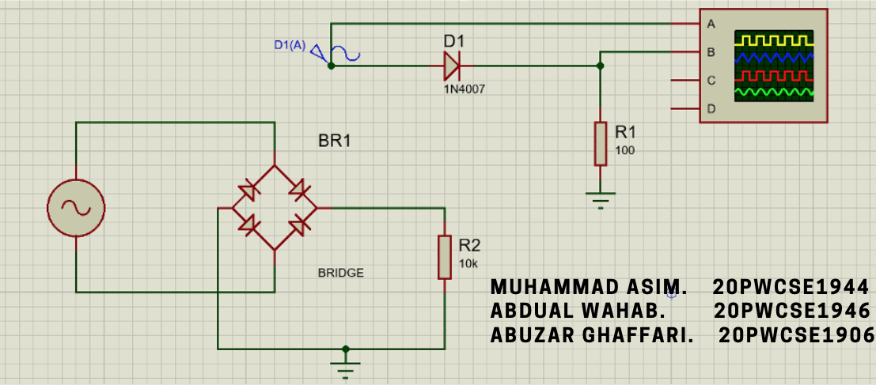

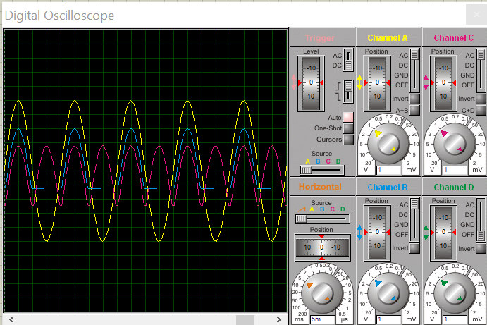The oscilloscope output is given bellow.

This snip has all values with vertical offset zero. I modified there vertical offsets in next snip so that they are well separated.

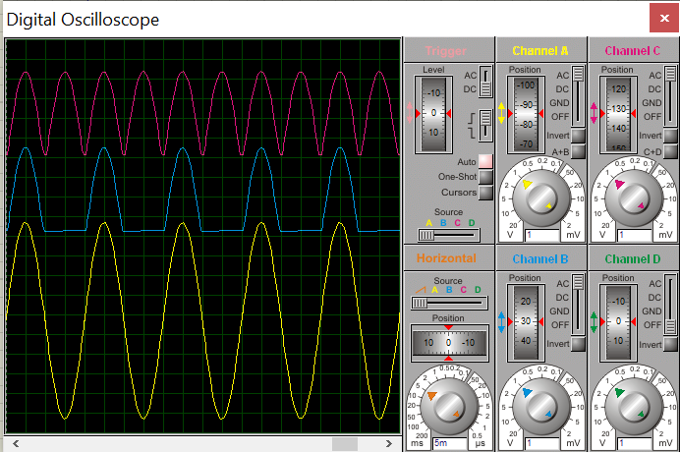

I then moved on to taking pdf prints for full wave, which are given at the end of this document. But first I will put PCB layouts.

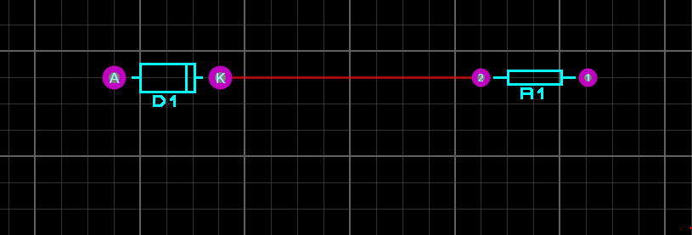

Figure 2: PCB Layout for half wave

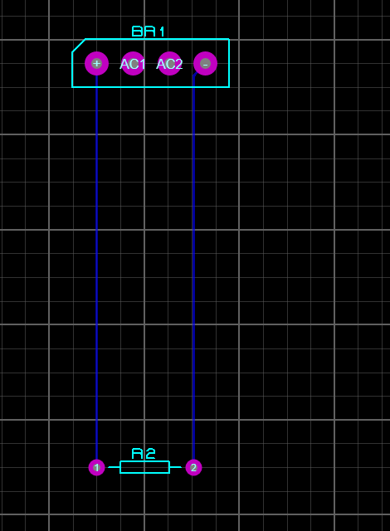

Figure 3: PCB Layout for full wave rectifier.

Next two pages are pdf prints of oscilloscope for full wave rectifier. The oscilloscope output of both these are shown on previous page.

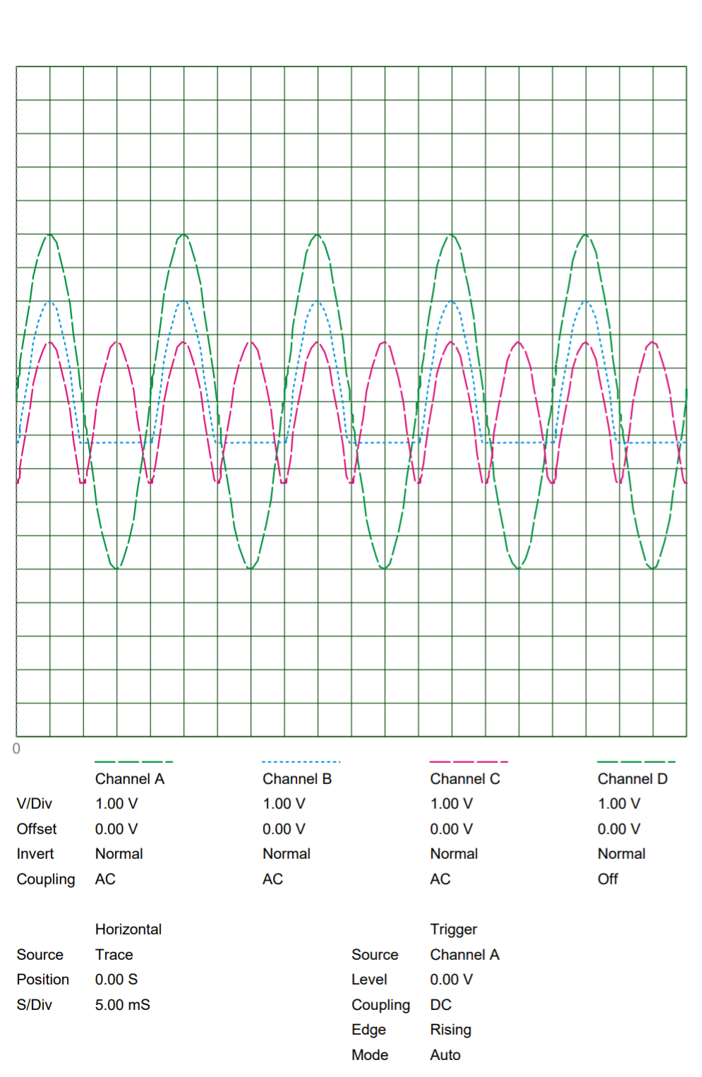

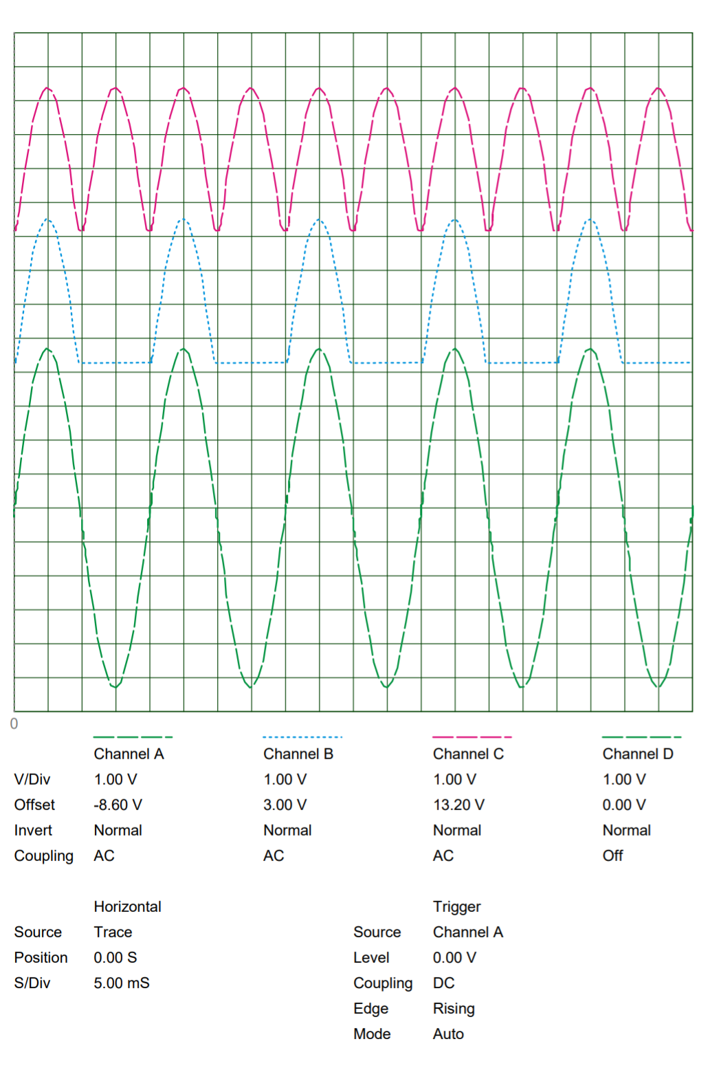

**Conclusions:**

In half wave rectification only, we get the output when the diode is forward biased, we get zero voltage at output when the diode is reversed biased it means we are throwing away the negative or blocked cycle of the waves. It means half wave is not so much effective in Ac to De conversion Vout-Vm-Vd.

Vdc Average of the output voltage will be 0 318 Vm Va) Vm is input voltage amplitude and Vd is voltage drop across diode.

In full wave rectification we use bridge rectifier which consist of four diodes. For a positive cycle two diode operate and for the negative cycle the other two diode operate. These diodes help in converting the AC to pulsating DC. Full wave rectification is efficient because we are using both the cycle of input and get a positive cycle output for both positive and negative cycle Vout-Vm-2Vd.

Vdc Average of the output voltage will be 0 636(Vm-2va)

2Vd because two diodes are used and we have to mmus them from input voltage Vm is input voltage amplitude and Vd is voltage drop across diode

**-------------------------------THE END-------------------------------**